**Statistical mathematics - Assignment 4**

1. a) A = {0, 1, 2}

b) B = {2, 3}

c) C1 = {3, 4, 5} C2 = {2, 3}

d) D = {0, 1, 2, 3, 4, 5}

e) E = ∞

1. a) $P_{X}\left(x\right)=\left\{\begin{aligned} 0.001 &if x=299 \\ 0.001 &if x=199 \\ 0.001 &if x=99 \\ 0.997 &if x=-1\end{aligned}\right.$

b) Pwin = P(299) + P(199) + P(99) = 0.003

1. a) RX = {2, 3, 4, 5, 6, 7, 8, 9, 10, 11, 12}

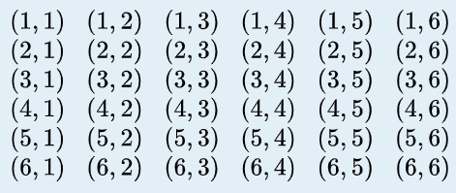b) $P_{X}\left(x\right)=\left\{\begin{aligned}\frac{1}{49} &if x=2 \\ \frac{2}{49} &if x=3 \\ \frac{3}{49} &if x=4 \\ \frac{4}{49} &if x=5 \\ \frac{5}{49} if x=6 \\ \frac{8}{49} if x=7 \\ \frac{7}{49} if x=8 \\ \frac{6}{49} if x=9 \\ \frac{5}{49} if x=10 \\ \frac{4}{49} &if x=11 \\ \frac{4}{49} if x=12\end{aligned}\right.$

1. a) Not valid: Probability cannot be negative.

b) Not valid: The sum of all probabilities equals 0.895.

c) Valid.

$\sum_{k≥1}{P\left(X=k\right)= \sum_{k≥1}{p{(1-p)}^{k-1} }}$

$$=p\left[1+\left(1-p\right)+{(1-p)}^{2}+…\right]$$

$=p\left[\frac{1}{1-(1-p)}\right]=p\frac{1}{p}=1$